**Sand Temple**

Written, Directed & Music

by

Vikas Dani



**Log Line**

A young boy of an Indian Slum desires to decorate his house the most beautiful one on the eve of Diwali festival. Inspired by his surrounding characters and overcoming all the obstacles including his poor economic condition, he must explore the true meaning of 'Joy of giving' in his beautiful and innocent journey..

**Synopsis**

Ampa, a 11 year old boy of an Indian slum located on a sea shore wants to decorate his house the most beautiful one on the eve of Diwali festival. His mother refuses to give him money giving the excuse of their poor economic condition. Sitting sad on the beach he comes across a blind old man carrying a dog and collecting waste bottles thrown on the beach. On inquiring he figures out a way of earning money by selling waste bottles. He spends next 3 days roaming and collecting waste bottles thrown over the beach. There he also meets a lot of interesting characters and explores a completely new world. One day before Diwali Old man again bumps into Ampa searching for his lost dog, but Ampa too is clueless about the dog. Running behind his dream and overcoming all the obstacles, he must realize the true meaning of joy of giving.

Director and Cast Biographies

**Vikas Dani (Writer, Director, Actor, Music Director & Producer)**

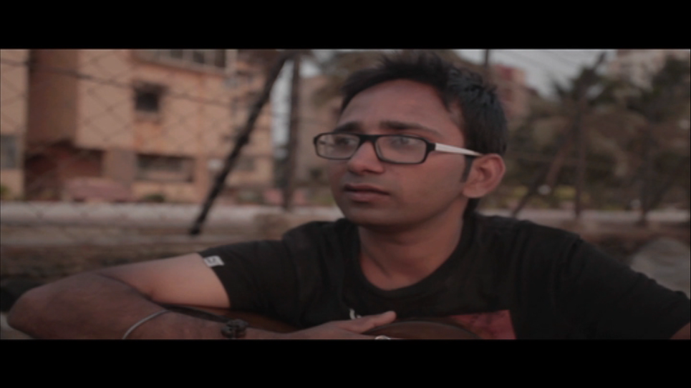

Born in a small town of Durg, Chattisgarh, Vikas Dani is a young aspiring Film maker, Writer, Musician and Actor. He passed his engineering from NIT, Durgapur and after working in a multinational company for a short period of time, he soon realized that his main passion lies in creating art rather than following a 9 to 6 schedule. He is a skilled classical guitar player and composer. Along with his Mumbai based folk band he also does live performance in local pubs. After making a short film “Bhaag 76” under his film school project, “Sand Temple” is his first individual venture.

Actors

**Adil Shaikh (Ampa)**

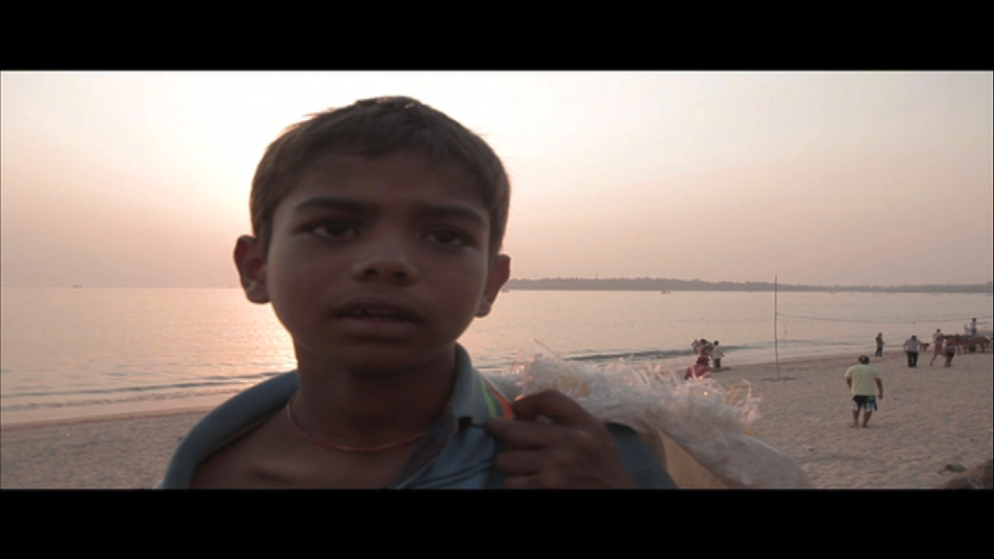

Adil Shaikh is a 12 year old kid and Studies in 6th standard. This is his first film as an actor.

**Raj Nili (Blind Old Man)**

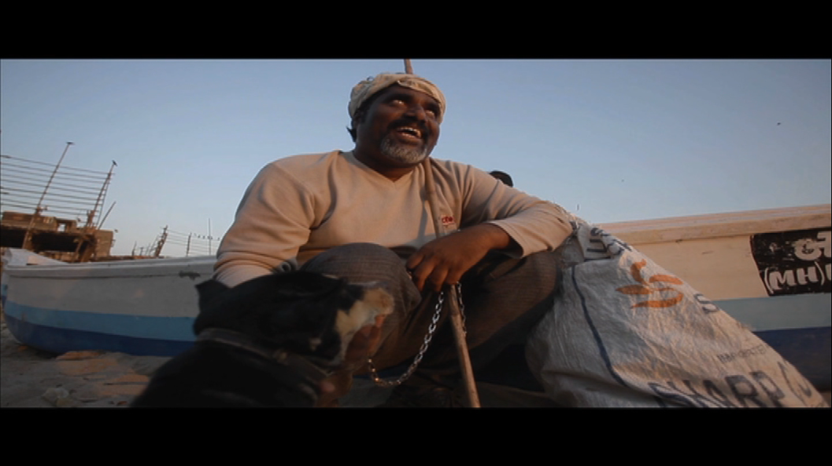

Raj Nili is a Marathi Theatre and Film Actor. He has done several short films , Plays and Films .

**Jenvanjyoti Doke (Maa)**

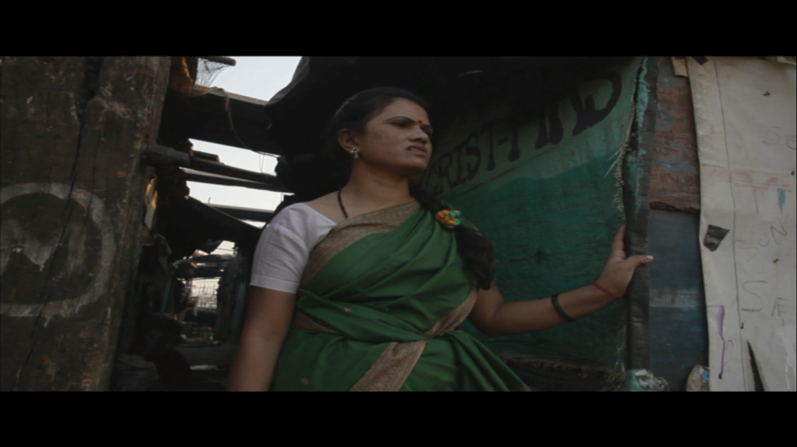

She is a Marathi theatre actor and has done several plays and some cameo roles in Marathi films.

**Sagar Kokitkar (Municipality Guy)**

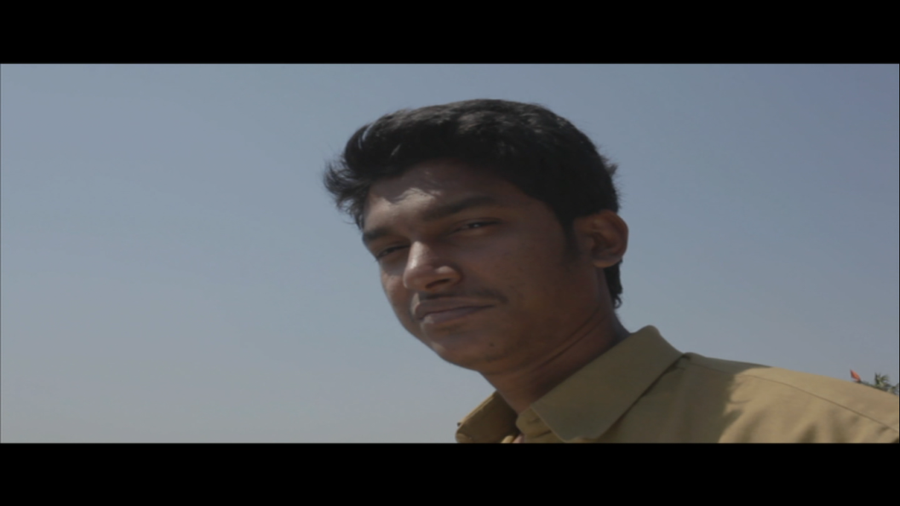

Sagar is an actor and writer. He has done several characters in various short films.

**Duffy (Damru)**

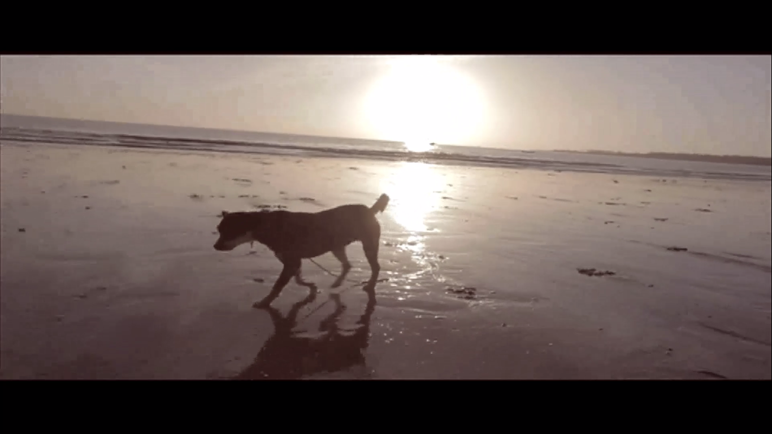

Duffy is a dog who lives by the sea side. This is his first film.

**Director Of Photography**

**Ashwyn Warrier**

He is a cinematographer and a photographer. He has studied photography from Light and Life Academy, Ooty and has done filmmaking course from Udaan, Byculla.

**Editor**

**Poonam Jadhwani**

She is an Editor and a professional photographer. She also used to teach VFX in the VFX school.

**Sound Design**

**Muktak Kanjilal**

Muktak Kanjilal is pursuing Sound engineering course from SAE, Mumbai.

**Post Production Audio Mix**

Shrivats Kulkarni

**Final Color Correction**

Nigel Fernandes